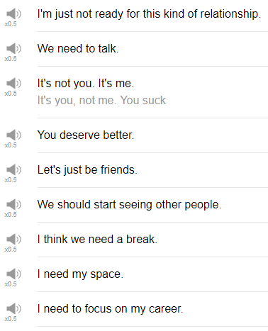

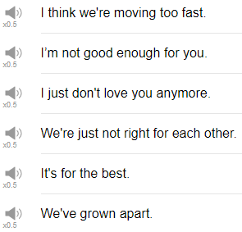

|  |
| --- |
| Hi, everybody! Welcome back to Top Words! My name is Alisha, and today we're going to be talking about 10 Break Up Lines. These are lines that you can use when you want to end a romantic relationship. Let's go! |
| 1. I need my space. |
| So if you feel the other person is maybe just always with you, always looking for time, or just bothering you, whatever, it doesn't matter. You don't want to spend time with that person anymore, you can say I need my space. Actually, I need my space. |
| 2. I need to focus on my career. |
| So maybe you're really really busy with work, or you're just looking for an excuse to break up with the person. To break up with someone you can say,I'm really sorry, but right now I need to focus on my career. |
| 3. I think we need a break. |
| This is after you've been seeing someone for some time, and you decide that maybe they're not the right person for you. You can say, I think we need a break. Be careful though, this phrase sounds like there's a chance you may get back together in the future. If you don't feel that there's a chance you will be continuing to see this person, maybe choose a different line to break up with them. |
| 4. I think we're moving too fast. |
| This is an expression you might use towards the beginning of a relationship, maybe for example, you meet someone and then you start dating them, and then a month later they're, like, let's move in together! And then three months later it's like, oh let's get married, or whatever. The pace of the relationship seems too fast, you can say "I think we're moving too fast." So if you say this phrase maybe it doesn't mean that you want to break up, but just this pace is too fast for me, let's slow down. |
| 5. I'm just not ready for this kind of relationship. |
| This could have many different meanings, maybe the relationship is very serious and you're not looking for a serious relationship. You can say "I'm not ready for this kind of relationship", saying I'm not ready sounds like it's me, it's my problem. I'm not ready for this kind of relationship. |
| 6. It's not you, it's me. |
| There's no problem with you, rather I have a problem. Maybe they're just struggling with some things that they're not... they don't want to bring into a relationship, or maybe they're just trying to be polite, maybe it is you, maybe it is you, but the other person is trying to be kind, so you can say "it's not you it's me". |
| 7. Let's just be friends. |
| You've been in a relationship with someone for a while and you decide maybe it's better if we don't date each other, but i still like this person so let's just be friends. |
| 8. We need to talk. |
| Oh no! We need to talk. The dreaded "we need to talk". If someone says we need to talk in that tone, we need to talk, or if you get like a text message that is we need to talk, it's never "we need to talk, I want to get a puppy". It's never a happy thing! If you see, if you hear "we need to talk" it's oh no something is bad at my relationship and i'm about to hear about it. dun dun dun and so you can follow we need to talk with a an actual issue that you need to discuss about your relationship, or it can mean the end of the relationship. You want to talk about ending the relationship. |
| 9. We should start seeing other people. |
| The next break up line is we should start seeing other people. Ouch! It means i don't want to see you anymore. Ah! One point about this, when we are in a relationship with someone, there are a couple of different verbs that we use. we use the verb seeing, to see someone; and to date, to go out with, those are a few. So in this expression, we see "we should start seeing other people" so it doesn't mean just like stand across the room I see another person, I see you! Hi! No, it means date, it means be in a relationship with. We use the verb "to see" for that, one of the things that is sad about this phrase is that if someone uses the phrase "we should start seeing other people" there's a good chance that person is already seeing someone else. Ouch! Ouch! |
| 10. You deserve better. |
| The next phrase is "you deserve better". Oh! So if someone says to you, you deserve better, like, I think we should end the relationship, you deserve better, it means that the person feels they are not good enough, they're not enough for you. And so they think you should find someone better than the person saying the phrase. Again this could be a sincere expression or it could just be a very polite and kind way to end a relationship with someone. |
| That's the end! Those are 10 phrases that you can use to break up or to discuss a serious matter in a relationship. I hope that you don't need to use these words, and i hope that you don't have to hear these words, but in case you do those are some of the things that the other person might be trying to communicate. So thank you very much for watching this episode of Top Words. Please please please be sure to subscribe, and we will see you again next time for more fun stuff. Bye! |
| So depressing! So depressing! We should start seeing other people. If I say in a happy voice and doesn't seem so sad. |